Celebrate Lunar New Year, Year of the Rooster
Chinese New Year is on January 28, 2017 - this day is the first new moon day of the first Chinese lunar month in the Chinese Lunar Calendar system. Chinese New Year is celebrated for sixteen days (from New Year's Eve to the Lantern Festival), with preparations several days before the New Year's Eve. Below is a daily guide to celebration activities in 2017.
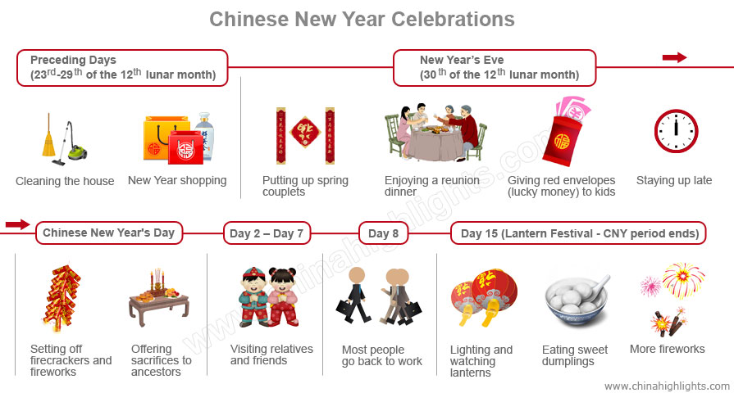

This weekend, several GALA families plan to attend the event at the Asian Town Center, 3820 Superior Avenue, Cleveland 44114. See details below:
When: Sunday, January 29, 2017
12:00 p.m. (noon) - Lion Dance and fireworks with performance by the Kwan Lion Dance team
1:30 p.m. – Dragon Dance performed by the Ohio Chinese Association (OCA) Dragon Dance Team
3:30 – 5:00 p.m. – FREE Tai Chi (open to all)
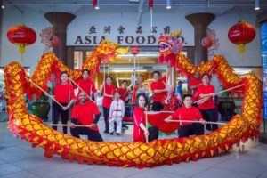
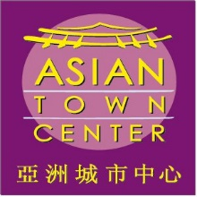
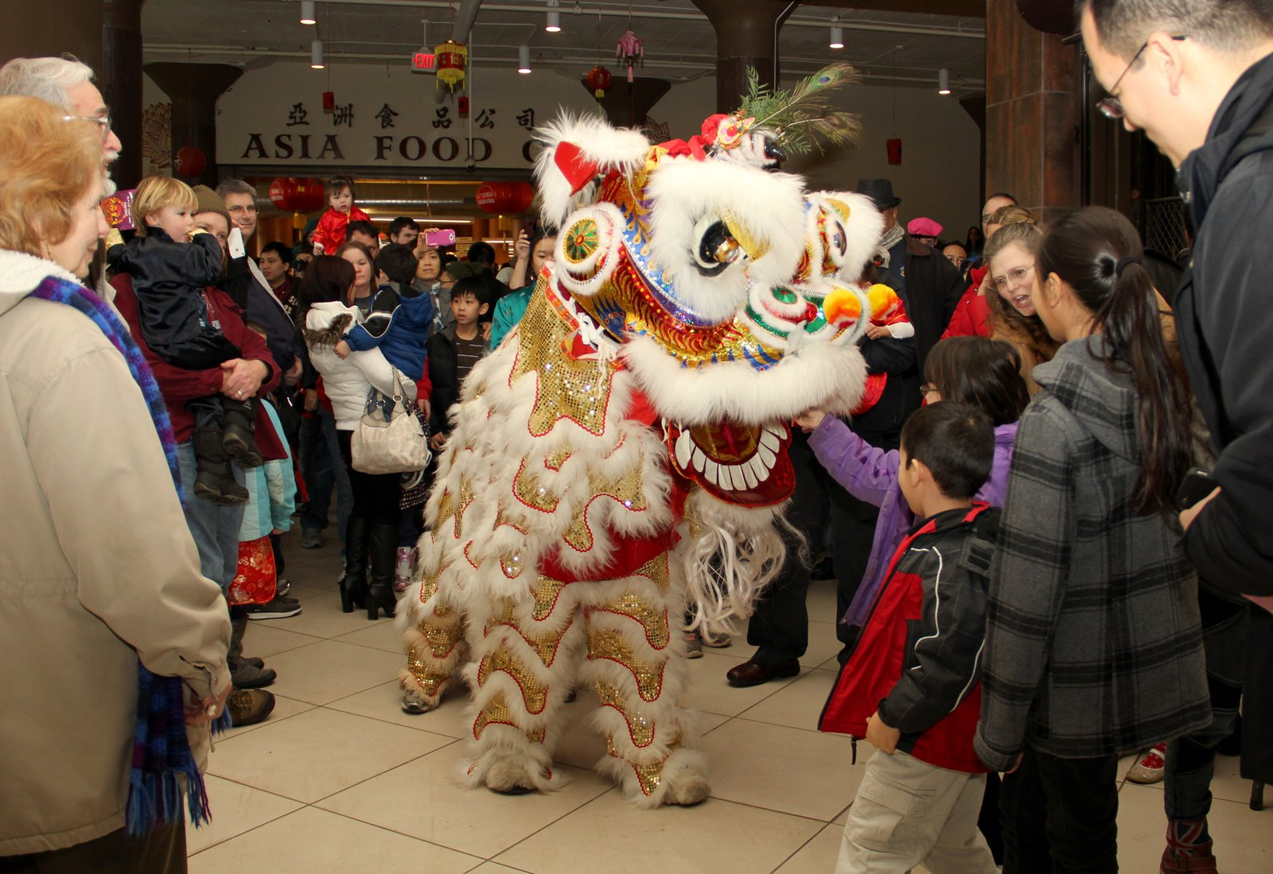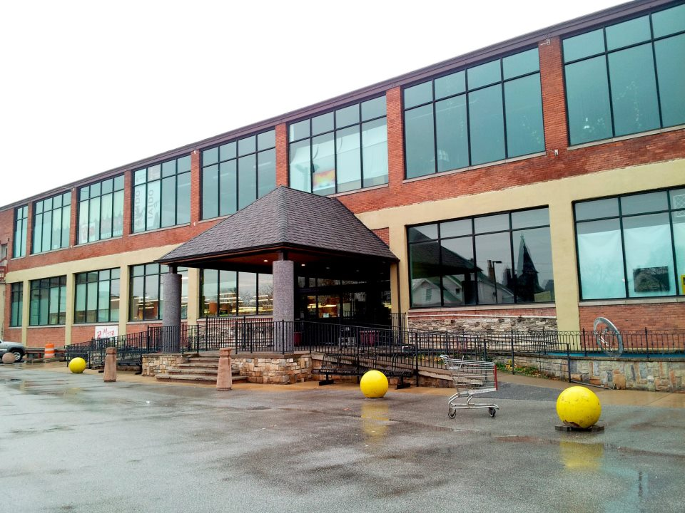

Below is a listing of the many celebrations ongoing throughout the Cleveland-area you can attend this weekend. Full listing of events through end of February at http://ocagc.org/?p=1826.
Fri. Jan. 27, 7 p.m. Kwan Family Lion Dance Performance, Li Wah by Restaurant in Asia Plaza, 2999 Payne Ave., Cleveland, Ohio. Reservations Required, call 216-696-6556.

Fri. Jan. 27, 7:30 p.m. Cleveland Cavaliers vs. Brooklyn Nets Chinese Lunar New Year Celebration with OCA Cleveland Dragon Dance Performance (3rd Quarter), Quicken Loans Arena, Cleveland, Ohio. #OCAdragon

Fri. Jan. 27, 8-9:30 p.m. Lunar New Year Fireworks, Freiberger Field by Tinkham Veale University Center, 11038 Bellflower Rd, Cleveland, Ohio. Free and Open to the community. #CWRULNY

Sat. Jan. 28, 10 a.m. -1 p.m. CAoC Chinese New Year Celebration 農曆新年慶祝活動, Chinese Academy of Cleveland, Shaker Heights Middle School, 20600 Shaker Blvd., Shaker Heights, Ohio. Sponsored by Overseas Community Affairs Council, Taiwan.

Sat. Jan. 28, 11 a.m. Kwan Family Lion Dance Performance, Li Wah Restaurant in Asia Plaza, 2999 Payne Ave., Cleveland, Ohio. Sorry, no reservations accepted.

Sat. Jan. 28, 1-3 p.m. Year of the Rooster Chinese New Year with the Kwan Lion Dance, Pearl of the Orient, 19300 Detroit Ave., Rocky River, Ohio. Call 440-333-9902 for reservations.

Sat. Jan. 28, 2-3 p.m. Chinese New Year Celebration, Chagrin Falls Branch, Cuyahoga County Public Library, 100 East Orange Street, Chagrin Falls, Ohio. Welcome Chinese New Year with stories, crafts and interactive fun! Free, Register HERE
Sat. Jan. 28, 2 p.m. Yin Tang Dance, Main Library Auditorium, Lakewood Public Library, 15425 Detroit Ave, Lakewood, Ohio.
Sat. Jan. 28, 3 p.m. Kwan Family Lion Dance Performance, House of Hunan, 18 Public Square, Medina, Ohio. Call (330) 722-1899 for Reservations.
Sat. Jan. 28, 3-4 p.m. Chinese New Year, Solon Branch, Cuyahoga County Public Library, 34125 Portz Parkway, Solon, Ohio. Celebrate culture surrounding Chinese New Year with stories, games, and crafts. Free, Register HERE
Sat. Jan. 28, 6 p.m. Kwan Family Lion Dance Performance, Bo Loong Restaurant, 3922 St Clair Ave NE, Cleveland, Ohio. Reservations Required, call 216-391-3113.
Sat. Jan. 28, 6-9 p.m. Lunar New Year Dinner Celebration, Yellow Tail Japanese Seafood Buffet, 4054 Medina Rd, Akron, Ohio. Yin Tang Dance Company, Dancing, Live DJ, Face Painting, Balloon Artist, Games, and Prizes. No Reservations required.
Sat. Jan. 28, 7:30 p.m. Kwan Family Lion Dance Performance, Vieng’s Asian Bistro at Crocker Park, 139 Crocker Park Blvd, Cleveland, Ohio. For reservations, call (440) 871-2888.
Sun. Jan. 29, 12 noon, Kwan Lion Dance Performance, Asian Town Center, 3820 Superior Ave. E, Cleveland, Ohio 44114. FREE Event, Free Parking.

Sun. Jan. 29, 1-9:30 p.m. Year of the Rooster Performances, Dinner, Raffle, and Games hosted by the Cleveland Contemporary Chinese Culture Association, Cleveland Contemporary Chinese School, Solon High School, 33600 Inwood Road, Solon, Ohio. Advance Dinner Tickets $8; Kids $4. *

Sun. Jan. 29, 1:30 p.m. OCA Cleveland Dragon Dance Team (in partnership with Confucius Institute at CSU). Asian Town Center, 3820 Superior Ave. E, Cleveland, Ohio 44114. FREE.
Sun. Jan. 29, 1:30 p.m. Kwan Family Lion Dance Performance, China Jade Restaurant, 2190 Brookpark Rd, Cleveland, Ohio. Call (216) 749-4720 for reservations.
Sun. Jan. 29, 5 p.m. Year of the Rooster Celebration with the Kwan Family Lion Dance, Hunan Solon, 6050 Enterprise Pkwy, Solon, Ohio. Call (440) 248-8836 for reservations.
Sun. Jan. 29, 5:30-8 p.m. MotivAsians Lunar New Year Dinner, Li Wah Chinese Restaurant, 2999 Payne Avenue, Cleveland, Ohio. RSVP HERE

Sat. Jan. 29, 7 p.m. Kwan Family Lion Dance Performance, Li Wah by Restaurant in Asia Plaza, 2999 Payne Ave., Cleveland, Ohio. Reservations Required, call 216-696-6556.

